भारत मौसम विज्ञान विभाग |  | India Meteorological Department
Sunday 24th May 2026 (03rd Jyaistha 1948 Saka)
Summary of observations recorded at 0830 hours IST: The Northern Limit of Monsoon continues to pass through 7°N/60°E, 7°N/70°E, 7°N/75°E, 8°N/80°E, 10°N/85°E, 13.5°N/90°E, and 17°N/95°E as on 24th May 2026. Conditions are favourable for further advance of southwest monsoon into some more parts of southwest & southeast Arabian Sea, Comorin Area, southwest, southeast & eastcentral Bay of Bengal and remaining parts of Andaman Sea during next 2-3 days. The Western Disturbance as a cyclonic circulation over Jammu & neighbourhood at 3.1 km above m. s. l. persisted. The upper air cyclonic circulation over south Bihar & neighbourhood persisted and seen at 0.9 km above m. s. l. The north - south trough from the upper air cyclonic circulation over southwest Bihar to north coastal Andhra Pradesh ran from south Bihar to north coastal Andhra Pradesh across Jharkhand and Odisha and extended upto 1.5 km above m. s. l. The upper air cyclonic circulation over central Assam & neighbourhood persisted at 0.9 km above m. s. l. The upper air cyclonic circulation over Southeast adjoining central Bay of Bengal lay over southwest Bay of Bengal & neighbourhood between 3.1 & 5.8 km above m. s. l. tilting southwestwards with height. A fresh Western Disturbance likely to affect Northwest India from 28th May, 2026. The trough ran from Punjab to Southwest Rajasthan became less marked. The trough in westerlies with its axis at 5.8 km above m. s. l. roughly along Long. 90°E to the north of Lat. 23°N moved away. The upper air cyclonic circulation over Southwest Arabian sea became less marked.
Maximum Temperature Departures (as on 23-05-2026): markedly above normal (> 5.1°C) at few places over East Madhya Pradesh; at isolated places over Bihar, West Uttar Pradesh, Himachal Pradesh, East Rajasthan, West Madhya Pradesh and Coastal Andhra Pradesh & Yanam. appreciably above normal (3.1°C to 5.0°C) at many places over East Uttar Pradesh; at few places over Jharkhand and Vidarbha; at isolated places over Sub Himalayan West Bengal & Sikkim, Gangetic West Bengal, Odisha, Uttarakhand, Haryana-Chandigarh-Delhi, West Rajasthan, Gujarat Region, Saurashtra & Kutch, Chhattisgarh, Telangana and Tamil Nadu, Puducherry & Karaikal. above normal (1.6°C to 3.0°C) at many places over Punjab; at few places over Konkan & Goa; at isolated places over Assam & Meghalaya, Nagaland, Manipur, Mizoram & Tripura and Madhya Maharashtra. near normal (-1.5°C to 1.5°C) at many places over Andaman & Nicobar Islands, Jammu-Kashmir-Ladakh-Gilgit-Baltistan-Muzaffarabad, Coastal Karnataka and Kerala & Mahe; at most places over Marathwada, North Interior Karnataka and Lakshadweep; at few places over Arunachal Pradesh and Rayalaseema. The highest maximum temperature of 47.1°C was reported at Brahmpuri (Maharashtra).
Hailstorm occurred at isolated places over Uttarakhand.
Heat wave conditions prevailed at many places over Vidarbha; at a few places over Chhattisgarh; isolated places over east Uttar Pradesh, east Madhya Pradesh, Odisha, West Rajasthan.
Warm night conditions prevailed in isolated pockets over East Uttar Pradesh.
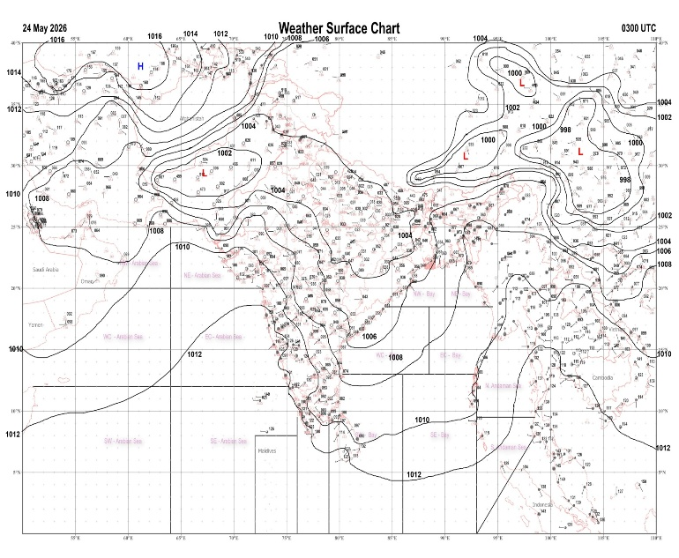 | 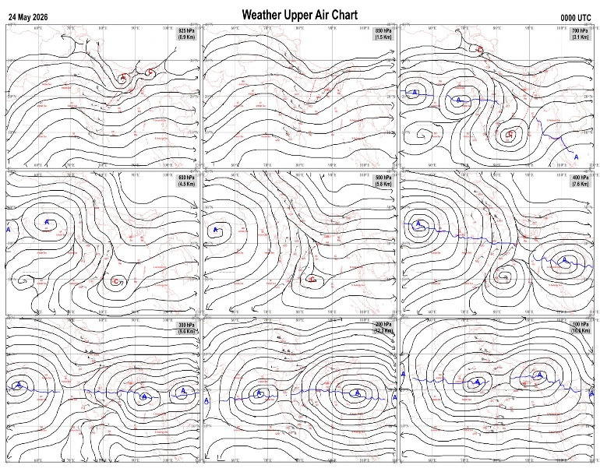
Fig.1. Analysed surface chart based on 03z observation | Fig.2. Analysed upper air chart based on 00z observation
V.K.Shripad
Scientific Officer ‘I’
CR & S Office, Pune  Issued at 1245 hrs. IST |  | Weather Forecasting Division  CR&S, Pune

Indian regions | Realised rainfall (chief amount in cm during past 24 hrs):
East | most places: Arunachal Pradesh, Assam & Meghalaya+++ and Sub-Himalayan West Bengal & Sikkim+  many places: Nagaland-Manipur-Mizoram-Tripura+  isolated places: Gangetic West Bengal, Odisha, Jharkhand and Bihar+  Karimganj AWS 18.5, B p ghat 15.3, Mangan 8.6, Silchar & Agartala AP 7.8 each, Met agartala AWS 7.7, Pranpur 7.5, Singhik 6.9, Udaipur 6.8, Hasimara 3.9, Katihar 3.3, Bomdila AWS 3.2, Pasighat AP 2.5, Tezu 2.4, Asansol 1.9, Keonjhargarh 1.6, Forbesganj 1.5, Rampurhat (DRMS) 1.3, Krishnanagar & Nuagaon 1.0 each, Danagadi & Zrs dumka 0.6 each, Pakuria 0.1.
North | isolated places: Uttarakhand◆, Haryana, Punjab, Himachal Pradesh, Jammu-Kashmir and Ladakh, west Rajasthan◆ and east Rajasthan◆  dry weather: Uttar Pradesh  Sunibhajji 2.3, Jogindarnagar 0.8, Ndri kvk AWS 0.7, Bandipora 0.5, Dhuri & Bhaderwah ARG 0.3 each, Mewat nuh AWS & Raj pura ARG 0.2 each, Bhatwari, Sriganganagar tehsil SR, Ganganagar & Alwar obs 0.1 each.
Central | dry weather: Madhya Pradesh, Vidarbha and Chhattisgarh
Peninsula | most places: coastal Karnataka+++ and north interior Karnataka+  many places: Kerala+  a few places: Konkan & Goa+ and south interior Karnataka  isolated places: Madhya Maharashtra, Marathwada, coastal Andhra Pradesh, Telangana, Rayalaseema and Tamil Nadu  dry weather: Gujarat State  Karwar 19.7, Manki 12.5, Devgad & Tavaragera 10.3 each, Nalwatwad 8.9, Mundgod 8.6, Munakkal AWS 8.0, Kankavli 7.0, Sattur & Sandur 5.7 each, Mancompu 5.6, Hunchadakatte 5.3, Dabolim n.a.s. navy & Rayadurg 5.2 each, Dharwad PTO 4.7, Aiza 4.2, Aspari 3.9, Ghattu 3.8, Chinnakalar 2.8, Kurnool & Kochi IAF 2.7 each, Sankh 2.0, Davanagere PTO 1.6, Mahbubnagar 1.3, Sangli & Dharashiv IMD parttime 0.9 each, Sholapur 0.7, Tuni & Madurai south 0.5 each, Parbhani 0.3.
Islands | most places: Andaman & Nicobar  many places: Lakshadweep  Nancowry & Agathi 1.6 each, Maya bandar 1.3, Long island 0.7, Minicoy 0.4, Amini 0.1.
Table-2 Forecast / warnings (distribution of rain / thundershowers) for 7 days (valid from time of origin upto 0830 hrs IST of next day)
Sr N. |  | Sub-division Name | Day 1 | Day 2 | Day 3 | Day 4 | Day 5 | Day 6 | Day 7 | Sr. No. | Sub-division Name | Day 1 | Day 2 | Day 3 | Day 4 | Day 5 | Day 6 | Day 7
 |  |  | 24 May | 25 May | 26 May | 27 May | 28 May | 29 May | 30 May |  |  | 24 May | 25 May | 26 May | 27 May | 28 May | 29 May | 30 May
 | 1 | Andaman Nicobar Islands | W  | W  | W  | W  | W | W  | W | 19 | west Madhya Pradesh | D + | D + | D + | D + | D + | I + | I +
 | 2 | Arunachal Pradesh | W ++  | W++ | W +  | W  | F  | S | S | 20 | east Madhya Pradesh | D + | D + | D + | D + | D + | I + | I +
 | 3 | Assam-Meghalaya | W  | W++ | W++ | W++ | F +  | F + | F | 21 | Gujarat region | D | D | D | D | D | D | D
 | 4 | Nagaland-Manipur-Mizoram-Tripura | F +  | F+ | F  | F  | F  | F | F | 22 | Saurashtra and Kutch | D | D | D | D | D | D | D
 | 5 | Sub Him West Bengal/Sikkim | W ++  | W+ | W+ | W+ | F  | S | S | 23 | Konkan and Goa | I  | I | I | I  | I  | I | I
 | 6 | Gangetic West Bengal | I  + | I  + | S  + | F  | F  | F  | S  | 24 | Madhya Maharashtra | I  | I  | I  | I  | I  | I | I
 | 7 | Odisha | I  + | I  + | I  + | I  + | I  + | I  | I  | 25 | Marathwada | I  | I  | D  | I  | I | I | I
 | 8 | Jharkhand | I  + | I  + | I  + | I  | S  | S  | S  | 26 | Vidarbha | D + | D + | D + | D + | I + | I + | I
 | 9 | Bihar | I +  + | S +  + | S +  + | S +  | S  | I  | I  | 27 | Chhattisgarh | D + | D + | I + | I  + | I  | I  | I 
 | 10 | east Uttar Pradesh | D + | I  + | I  + | I  + | S  + | S  | I | 28 | Coastal Andhra Pradesh and Yanam | I  + | I  | I  | I  | S  | S | S
 | 11 | west Uttar Pradesh | I  + | D + | D + | D + | I+ | S  | S  | 29 | Telangana | I + | I  + | I + | I  | I  | I | I
 | 12 | Uttarakhand | I  | I  | I | I | I | S  | S  | 30 | Rayalaseema | S  | S  | S  | S  | S  | S | S
 | 13 | Haryana,Chandigarh and Delhi | I  + | D + | D + | D + | I+ | S  | S  | 31 | Tamil Nadu, Puducherry and Karaikal | I +  | I +  | I+ | I  | I  | I | I
 | 14 | Punjab | I  + | D + | D + | D + | I+ | S  | S  | 32 | Coastal Karnataka | W+ | F  | S  | S  | S  | S | S
 | 15 | Himachal Pradesh | I  | S  | D + | D + | S  + | F  | S  | 33 | North interior Karnataka | S +  | S +  | I  | I  | I  | S | S
 | 16 | Jammu-Kashmir and Ladakh | S  | S  | D + | D + | S  | S  | I  | 34 | South interior Karnataka | F + | S +  | S  | S  | S  | S | S
 | 17 | west Rajasthan | I+ | D + | D + | D + | D + | D + | I+ | 35 | Kerala and Mahe | W+ | W +  | W+ | W+ | W+ | W | W
 | 18 | east Rajasthan | I+ | D + | D + | D + | D + | D + | I + | 36 | Lakshadweep | W+ | W +  | W+ | W+ | W | W | W
Legends: D = Dry I =isolated S = Scattered F = Fairly widespread W = Widespread #= heavy to very heavy rain at a few places with extremely heavy rain at isolated places+++= heavy rain at a few places with very heavy rain at isoIated places++= heavy to very heavy rainfall @=isolated exceptionally heavy rainfall+ = heavy rain ●/*= rain or snow ♦ = very light rain ≡=fog = thunderstorm with lightning =Squall / Gusty / gale / strong wind -=cold wave/cold day + = heat wave/warm night/hot and humid weather =Duststorm =ground frost = Hail.

Fig. 4: Districtwise warnings for five days for Maharashtra State
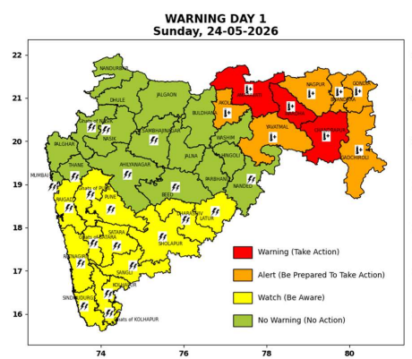 | 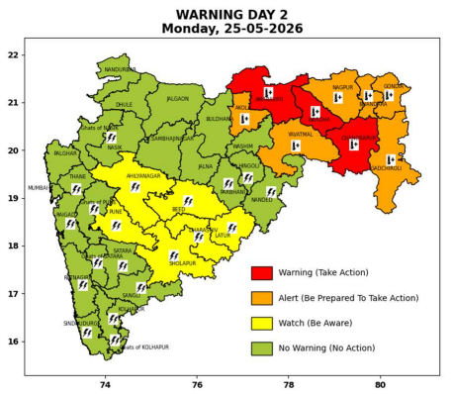 | 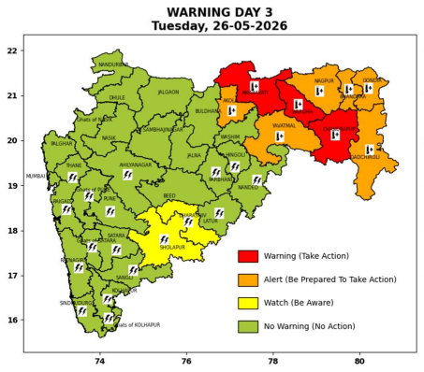 | 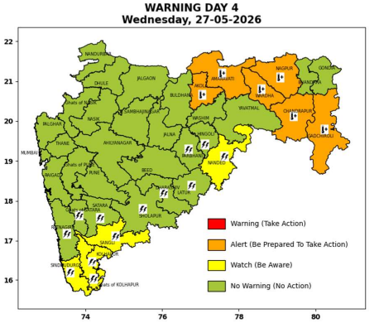 | 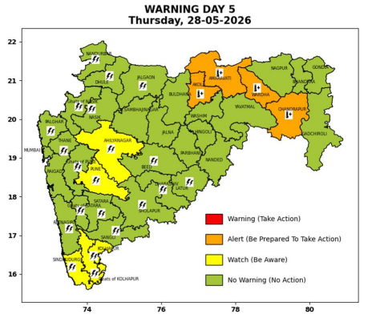

Pune, Lohegaon and Pashan observations at 0830 hrs. IST of Today
 | Temperature (°C) |  |  |  |  | Humidity (%) |  |  |  | Rainfall (mm)
 | Max.  past  24 hrs | Dep.  from  normal | Min.  past  24 hrs. | Dep.  from  normal | Dry  Bulb | At 0830 hrs. IST | Dep.  From  normal | At 1730  hrs. IST of ‘y’day | Dep.  from  normal | Past  24 hrs. | Since  1st March | Dep.  from  normal
PNE | 34.7 | -1.9 | 25.4 | 1.7 | 28.0 | 72 | 9 | 62 | 22 | 0.0 | 106.1 | 70.4
PSN | - | - | - | - | - | - | - | - | - | - | - | -
LHG | 34.8 | -1.2 | 25.6 | 4.6 | 28.2 | 73 | 10 | 56 | 17 | 0.0 | 107.6 | 63.8

 |  |  |  |  |  |  | Local (Pune and neighbourhood) forecast
Max./Min. Temperature (°C) |  |  |  |  |  |  |  |  | Weather
Date | Pune | Pashan | Lohegaon | Chinchwad | Lavale | Magarpatta | NDA | Koregoan park
24/05/26 | 35 / 25.4* | 34 / - | 36 / 25.6* | 34 / 25.8* | 34 / 22.8* | 37/ 25.2* | 33 / 25.0* | 36 / 26.8* | Mainly clear sky becoming partly cloudy sky towards afternoon or evening. Thunderstorm with lightning, light rain very light.
25/05/26 | 36 / 25 | 36 / 25 | 37 / 26 | 35 / 26 | 35 / 23 | 39 / 25 | 35 / 25 | 37 / 27 | Mainly clear sky becoming partly cloudy sky towards afternoon or evening. Thunderstorm with lightning, light rain very light.
26/05/26 | 36 / 25 | 36 / 25 | 37 / 26 | 35 / 26 | 35 / 23 | 39 / 25 | 35 / 25 | 37 / 27 | Mainly clear sky becoming partly cloudy sky towards afternoon or evening.
27/05/26 | 37 / 25 | 37 / 25 | 38 / 26 | 36 / 26 | 36 / 23 | 39 / 25 | 36 / 25 | 38 / 27 | Mainly clear sky becoming partly cloudy sky towards afternoon or evening.
28/05/26 | 37 / 26 | 37 / 26 | 38 / 27 | 36 / 27 | 36 / 24 | 40 / 26 | 36 / 26 | 38 / 28 | Mainly clear sky becoming partly cloudy sky towards afternoon or evening.
29/05/26 | 38 / 26 | 38 / 26 | 39 / 27 | 37 / 27 | 37 / 24 | 40 / 26 | 37 / 26 | 39 / 28 | Mainly clear sky becoming partly cloudy sky towards afternoon or evening.
30/05/26 | 38 / 26 | 38 / 26 | 39 / 27 | 37 / 27 | 37 / 24 | 40 / 26 | 37 / 26 | 39 / 28 | Mainly clear sky becoming partly cloudy sky towards afternoon or evening.
Rainfall Distribution |  |  |  |  | Rainfall Categories | Rainfall (mm) | Cloud condition |  | Rainfall Intensity | Range
Widespread (W) | 76-100% |  |  |  | Very Light rain | Trace to 2.4 mm | Mainly clear sky | 1-2 oktas | Light Spell | 1 cm/hr
 |  |  |  |  | Light rain | 2.5 to 15.5 mm | Partly cloudy sky | 3-4 oktas | Moderate Spell | 1-2 cm/hr
Fairly Widespread (FW) | 51 – 75% |  |  |  | Moderate rain | 15.6 to 64.4 mm | Generally cloudy sky | 5-7 oktas | Intense Spell | 2-3 cm/hr
Scattered (S) | 26 – 50% |  |  |  | Heavy rain | 64.5 to 115.5 mm | Overcast | 8 oktas | Very Intense Spell | 3-5 cm/hr
Isolated (I) | 1 – 25% |  |  |  | Very heavy rain | 115.6 to 204.4 mm |  |  | Extremely Intense Spell | 5-10 cm/hr
Dry (D) | No Rain |  |  |  | Extremely heavy rain | ≥ 204.5 mm |  |  | Cloudburst | > 10 cm/hr
Probability Terms in %: |  |  |  |  | Heavy snow | 6.5 to 11.5 cms water equivalent of rain
unlikely | < 25 |  |  |  | Very heavy snow | 11.6 to 20.4 cms water equivalent of rain
likely | between 25 50
very likely | between 51 75
most likely | >75
* = realized temperature
Mumbai (Colaba) |  |  |  | Nagpur (AP)
Date 2026 | T max °C | T min °C | Weather | T max °C | T min °C | Weather
24/05/26 | 33 | 27 | Generally cloudy sky with Light Rain or Drizzle. | 46 | 29 | Heat Wave.
25/05/26 | 34 | 27 | Partly cloudy sky. | 45 | 29 | Heat Wave.
26/05/26 | 35 | 27 | Clear sky. | 45 | 29 | Heat Wave.
27/05/26 | 35 | 27 | Clear sky. | 46 | 28 | Heat Wave.
28/05/26 | 34 | 27 | Clear sky. | 45 | 28 | Heat Wave.
29/05/26 | 34 | 27 | Clear sky. | 45 | 30 | Heat Wave.
30/05/26 | 34 | 27 | Clear sky. | 45 | 30 | Heat Wave.

